
Program of Studies
2016-2017

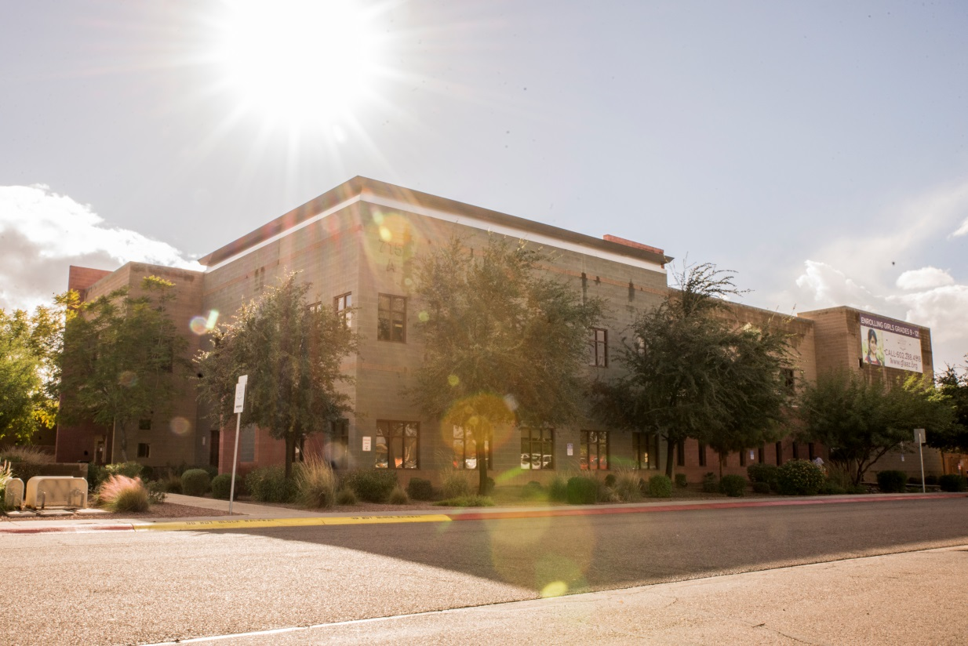

Table of Contents
Contents
Introduction 4
Graduation Requirements 5
AVID 6
Standardized Testing 7
AIMS Science 7
AzMERIT 7
PSAT 7
SAT 7
ACT 7
GLAAZ Academic Worksheet 8
ECAP(Education and Career Action Plan) 9
Service Hours Log Sheet 11
College Admissions 12
Student Athletes 14
Powerschool 15
AGEC 16
Site Map 18
Courses 19
AVID 19
AVID 9 19
AVID 10 19
AVID 11 19
AVID 12 19
English 20
English 9 20
English 10 20
English 11 20
English 12 20
AP Literature 20
English 101 - (concurrent enrollment) 21
English 102 - (concurrent enrollment) 21
Mathematics 21
Algebra 1 21
Geometry 21
Algebra 2 21
PreCalculus 21
Personal Finance 22
Calculus 22
Statistics/AP Statistics 22
Pre Calculus- MAT 187 (concurrent enrollment) 22
Calculus with Analytic Geometry – MAT 220 (concurrent enrollment) 22
Brief Calculus – MAT 212 (concurrent enrollment) 22
Science 23
Integrated Science 23
Biology 23
Chemistry 23
Physics 23
Biotechnology 23
Environmental Science/AP Environmental Science 24
Social Studies 24
Global Geography 24
World History 24
US History 24
Economics 24
Government 25
World Language 25
Spanish 101 - (concurrent enrollment) 25
Spanish 102 - (concurrent enrollment) 25
Electives 25
Creative Writing 25
Current Events 25
Drama 26
Health 26
Public Speaking 26
Publication and Production 26

Introduction

This Program of Studies has been created to help the parents and students of GLAAZ navigate the complexities, requirements, expectations and possibilities of our High School. As always, the GLAAZ staff is available to assist you but it is our hope that this document will allow you to more clearly understand the high school/early college/post-secondary process.

Graduation requirements are listed in order for you to closely follow your progress. Included is an Academic Worksheet for you to track your progress towards graduation. Standardized tests are listed. Note that several of these tests are high school requirements, while the remainder are part of the post-secondary application process.

Course descriptions are included in this document along with a detailed explanation of AVID, our required college preparatory curriculum. GLAAZ Policies and Procedures regarding academics are found in the Student Handbook.

We have provided you with a general outline of college admission requirements, as well as, the requirements if a student intends to compete in athletics at the Division I or II level.

Arizona General Education Curriculum (AGEC) is a 35-38 credit general education certificate that fulfills lower-division general education requirements for students planning to transfer to any Arizona public community college or university. The vast majority of these credits will also transfer to private and out-of-state college and universities. This information is helpful for our students who are enrolled in college classes with Phoenix College.

There is a lot of information packed into this document; however, we are always available to answer your questions, to meet with you and to advise you on the next steps of your GLAAZ education.

Graduation Requirements

GIRLS LEADERSHIP ACADEMY OF ARIZONA
GRADUATION REQUIREMENTS

ENGLISH | 4.0 Credits
MATH | 4.0 Credits
SCIENCE | 3.0 Credits
WORLD HISTORY | 1.0 Credits
FINE ARTS/C.T.E. | 1.0 Credits
US/AZ HISTORY | 1.0 Credits
FREE ENTERPRISE/ECONOMICS | 0.5 Credits
AMERICAN GOVERNMENT | 0.5 Credits
ELECTIVE CREDITS** | 8.0 Credits
TOTAL CREDITS REQUIRED | 23.0 Credits

**Elective Credits Recommended: World Language 2.0 Credits
AVID 4.0 Credits
Public Speaking 0.5 Credits
Health 0.5 Credits

25 HOURS OF COMMUNITY SERVICE EACH SCHOOL YEAR

AVID

AVID Mission Statement:
AVID's mission is to close the achievement gap by preparing all students for college readiness and success in a global society.

What does it mean to be an AVID school?
AVID, Advancement via Individual Determination, is an elementary through postsecondary college readiness system that is designed to increase school wide learning and performance. The AVID system accelerates student learning, uses research based methods of effective instruction, provides meaningful and motivational professional development, and acts as a catalyst for systemic reform and change.
At GLAAZ, we believe that all students benefit from completing the AVID curriculum. Students will be enrolled in an AVID class each year they attend GLAAZ. Students will learn many skills that will promote their success in college:
Study Techniques and Habits
Organizational Skills
Critical Reading Strategies
Annotation and Summary Writing
Problem Solving Strategies
Test Taking Skills
College Application Practice
Writing a Personal Statement
Presentation Skills
Research Skills

For more information about our AVID program, please look to the course descriptions on page 19.

Standardized Testing

AIMS Science
Administered to all Biology students

AzMERIT
AzMERIT is an end of course assessment. Students enrolled in English 9, English 10,and English 11 will take the English Language Arts Assessment. Students enrolled in Algebra I, Geometry and Algebra II will take the end of course assessment. At this time AzMerit is not a graduation requirement.

PSAT
Preliminary SAT – a standardized test that gives you a measurement on your preparedness for college. All 9th, 10th, and 11th grade students will take the PSAT. Juniors’ scores on the PSAT can qualify them for the National Merit Scholarship Program. The test is administered in October.
Register at www.collegeboard.com

SAT
Most students take the SAT during their junior and/or senior year in high school. At least half of all students take the SAT twice — in the spring of their junior year and in the fall of their senior year. Most students improve their score the second time around. Register at www.collegeboard.com

ACT
American College Testing ] college readiness assessment is a standardized test for high school achievement and college admissions in the United States.
Register at www.actstudent.org

GLAAZ College Board Number is: 030553

GLAAZ Academic Worksheet
NAME: __________________________________________________ CLASS OF 20____
(Minimum of 23 credits needed to earn High School Diploma)
LANGUAGE ARTS: (4 credits min.) ELECTIVES: (minimum of 8 credits)
English 9A _____ English 9B _____ _____________ _____ ______________ _____
English 10A _____ English 10B _____ _____________ _____ ______________ _____
English 11A _____ English 11B _____ _____________ _____ ______________ _____
English 12A _____ English 12B _____ _____________ _____ ______________ _____
_____________ _____ ______________ _____
MATHEMATICS: (4 credits min.) _____________ _____ ______________ _____
Algebra 1-A _____ Algebra 1-B _____ _____________ _____ ______________ _____
Geometry A _____ Geometry B _____ _____________ _____ ______________ _____
Algebra 2-A _____ Algebra 2-B _____ _____________ _____ ______________ _____
Math _____ Math _____
SOCIAL STUDIES: (3 credits min.)
CREDIT SUMMARY
Total Credits ____/____/_____ 9
Total Credits ____ /____/_____ 10
Total Credits ____/____/_____ 11
Total Credits ____/____/_____ 12
World History 1 _____ World History 2 _____
US History 1 _____ US History 2 _____
Economics _____ Government _____
SCIENCE: (3 credits min.)
Int Science A _____ Int Science B _____
Biology 1 _____ Biology 2 _____
Chemistry 1 _____ Chemistry 2 _____
COMMUNITY SERVICE HOURS
9TH GRADE ___________________
10TH GRADE ___________________
11TH GRADE ___________________
12TH GRADE ___________________
Science _____ Science _____
WORLD LANGUAGE:
________ _____ _____ ________ _____ _____
________ _____ _____ ________ _____ _____
FINE ARTS: (1 Credit FA and/or CTE)
_____________ ____ _____________ _____

ECAP(Education and Career Action Plan)
The ECAP is both a documented plan and a process that students use with support from school counselors, teachers and parents to clarify their career goals and to refine their postsecondary plans. It helps guide their decisions about the courses and activities they choose throughout high school.

We, as educators, believe that integrating an Education and Career Action Plan (ECAP) process into all facets of the school experience enables students to be lifelong learners and problem-solvers, developing and applying 21st century skills to their life experiences, as students, as workers, as consumers, and as responsible citizens. With the ability to identify skills and interests and to apply that knowledge to create their own ECAP, our students will have developed needed skills to advance in a more fluid, seamless transition, meeting 21st Century technologies and work place postsecondary requirements. Arizona Department of Education (ADE) – 2008

Your child will receive an ECAP user name and password when she enrolls in GLAAZ,
Your assistance in keeping this ECAP current is important to you and your child.
https://azcis.intocareers.org/materials/portal/home.html

Arizona Education and Career Action Plan

Attributes
An Arizona Education and Career Action Plan shall, at minimum, allow students to enter, track and update the following information:

ACADEMIC
• Plan coursework to explore interests and develop skills
• Meet all high school graduation requirements
• Review progress at least once a grading period
• Track needed interventions, advisements and supports
• Record academic achievements or awards
• Document postsecondary education goals
• Participate in fine arts programs, dual credit courses, honors placements

Continued on following page

CAREER
• Identify career options based on interests, values, and skills
• Explore career opportunities through research and out of school opportunities
• Document a career goal and needed educational requirements
• Participate in career and technical education courses
• Understand the Arizona Workforce projections
• Participate in work experiences, internships, job shadowing

POSTSECONDARY
• Explore admissions requirements for technical schools, community colleges, universities, including any college readiness tests such as ACT, SAT
• Compare postsecondary institution offerings
• Complete and submit necessary applications
• Create a financial assistance plan
• Complete a personal resume for college & employment

EXTRACURRICULAR
• Clubs, organizations or CTSO
• Athletics /Recreational activities
• Fine arts opportunities
• Civic and community service or volunteer activities
• Leadership opportunities
• Other activities the student might wish to note

Service Hours Log Sheet

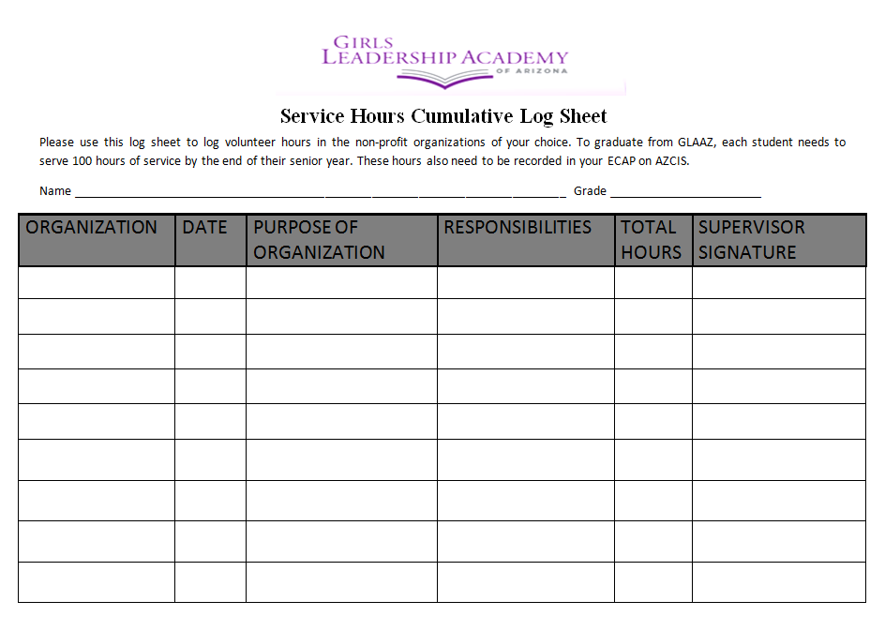

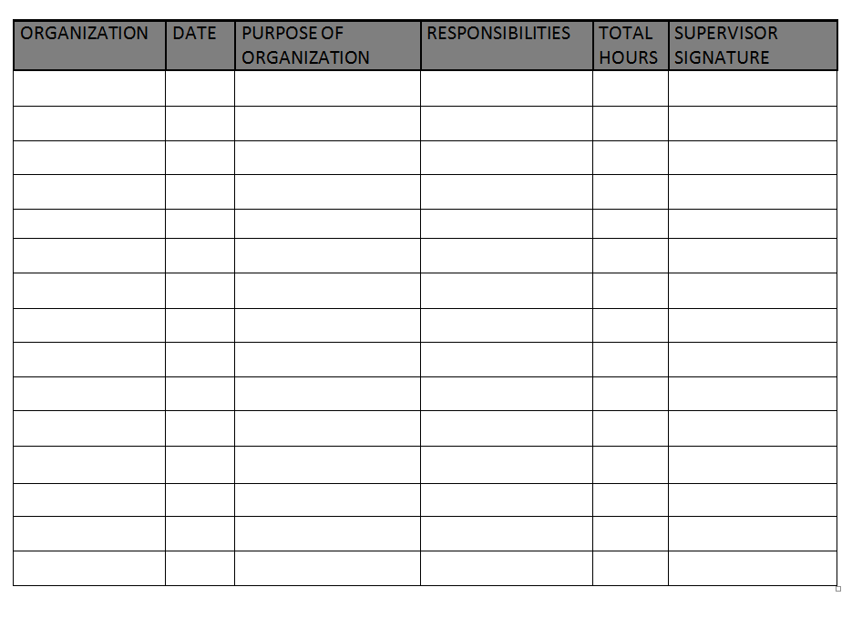
College Admissions
IN-STATE AND HIGHLY SELECTIVE UNIVERSITY/COLLEGE REQUIREMENTS

SUBJECT | HIGH SCHOOL DIPLOMA  GLAAZ | IN-STATE UNIVERSITY/COLLEGE COMPETENCIES | HIGHLY SELECTIVE PROGRAMS/UNIVERSITIES
English | 4 Credits | 4 Credits  (College Prep Literature Based | 4 Credits  Honors level preferred
Social Studies | 3 Credits  World History, US History, American Government, Economics | 2 Credits  American History and one other | 3 Credits  Honors levels preferred
Science | 3 Credits | 3 Lab Credits (any level Earth Science, Biology, Chemistry, Physics) | 4 Credits  Honors level preferred
Math | 4 Credits  Alg. I, Geo., Alg. II, and any other math course which contains significant math skills | 4 Credits  Alg. I, Geo., Alg II, any another course which Alg. II is a prerequisite | 4 Credits  Honors level preferred, Calculus preferred
World Language | 2 Credits  2 HS or 8 hours of college credit | 2 Credits of the same language | 3-4 Credits Recommended  Honors level preferred
CTE/Fine Arts | - Credit  Any combination of Fine Art and CTE | 1 Credit of Fine Arts  (2 semesters in same program area) | Consecutive courses  (2 semesters in same program area)
Electives | 8.0
Graduation Credit Graduation Requirement | 23 credits hours | 16 Core Classes  (plus additional credits to satisfy graduation requirements) | 18-19 Core Classes  (plus additional credits to satisfy graduation requirements)

Student Athletes
NCAA Initial Academic Clearinghouse for Prospective Student Athletes Interested in Division I and II Colleges and Universities

Students who are considering the possibility of participating in college or university athletics, or have the potential to receive an athletic scholarship during their first year of college, must be cleared by the NCAA Eligibility Center prior to graduation with their class. Students should contact their counselor/administrator for assistance with the process, preferably during their sophomore athletic season or as early as possible in the fall of their junior year. Students and parents are encouraged to visit the NCAA website at www.eligibilitycenter.org. Information for college-bound student athletes will be found under the Academic & Athletics Eligibility and Recruiting sections.

Students who plan to enter a Division I or II college or university and want to participate in athletics or receive an athletic scholarship during their first year must have:

- Graduated from high school
- Completed these 16 core courses:
  - 4 years of English
  - 3 years of mathematics (Algebra 1 or higher)
  - 2 years of natural/physical science (one must be a lab science)
  - 1 year of additional math, English or science
  - 2 years of social studies
  - 4 years of additional core courses (from any area listed above or from World Language, non-doctrinal religion or philosophy). Students should meet with their counselor or administrator for non-traditional courses.
- Earned a combined SAT or ACT sum score that matches their core-course grade point average and test score sliding scale found on the NCAA website (for example: a 2.40 core-course grade point average needs a 860 SAT); and earned a minimum required grade point average in their core courses.

To determine which high school courses meet the NCAA Clearinghouse requirements a student should go online to: www.ncaaclearinghouse.net.

Click on Prospective Student Athletes
Click on the List of Approved Courses (48-H Form)

Powerschool

Parents and students have the ability and are encouraged to monitor their student’s grades through Powerschool online. At the beginning of the school year, each student will receive a username and password that both student and parent can use to access grades online.
There are several ways to access the information. Online, go to:
www.crittenton.powerschool.com/public


Alternatively, you can download the Powerschool App for your smartphone or tablet (both iOS and Android).
- Download the Powerschool App from the App store
- Enter the school code LTPR
- Enter your students username and password (provided at beginning of school year)

For more information about GLAAZ grading and academic policies and practices, please refer to the student handbook.

AGEC
The Maricopa Community College District General Education Curriculum (MCCCD AGEC) is a 35-38 credit general education certificate that fulfills lower-division general education requirements for students planning to transfer to any Arizona public community college or university. There are three types of MCCCD-AGECs. They are the AGEC A, AGEC B and the AGEC S. Designed to articulate with different academic majors, the requirements vary accordingly (http://www.maricopa.eduacademic/ccta/curric/ac/agec09.doc).

MCCCD Student Catalogue – AGEC Requirements
http://www.pvc.maricopa.edu/catalogs/catalog2012/d_12_pvcc_educational_programs.pdf

AGEC-A is a block of general education courses for liberal arts majors:
First Year Composition 6 credits (Eng 101/102)
Mathematics - 3 credits (Math 140 or higher)
Arts & Humanities - 6-9 credits (One FA/One Humanities)
Social & Behavioral Sciences - 6-9 credits (Two different departments)
Physical & Biological Sciences - 8 credits (Two lab sciences)
Options - 6 credits
35 Credit Hours
AGEC-B is a block of general education courses for business majors:
First Year Composition- 6 credits (Eng 101/102)
Mathematics- 3 credits (Math 210 or higher)
Arts & Humanities- 6-9 credits (One FA/One Humanities)
Social & Behavioral Sciences- 6-9 credits (Two different departments)
Physical & Biological Sciences- 8 credits (Two lab sciences)
Computer Literacy 3 credits (CIS 103 or higher)
Options- 0-3 credits
35 Credit Hours
AGEC-S is a block of general education courses for business majors:
First Year Composition- 6 credits (Eng101/102)
Mathematics- 6-8 credits (Math 220 or higher)
Arts & Humanities- 6 credits (One FA/One Humanities)
Social & Behavioral Sciences- 6 credits (Two different departments)
Natural Sciences- 8 credits (Two lab sciences-Chm,Phy, Bio)
Options- 0-4 credits
35 Credit Hours

*****The following page contains the AGEC General Studies Transferable List*****

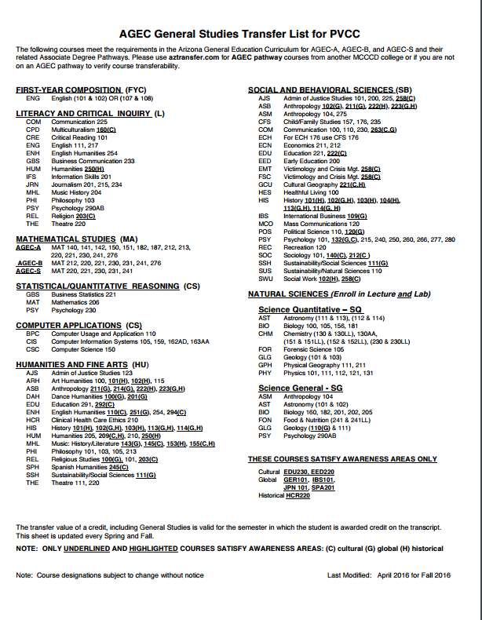

Site Map
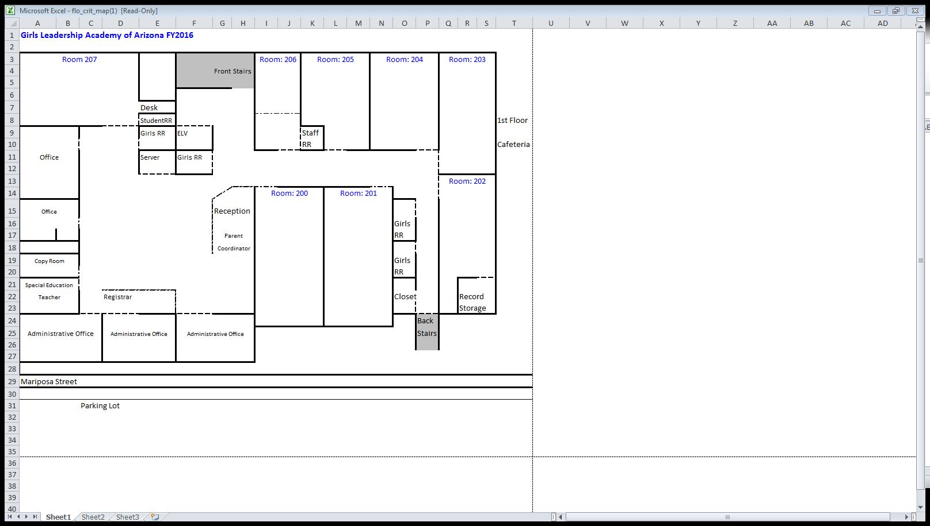

Courses

AVID
The AVID (Advancement Via Individual Determination) Elective course is a yearlong class that is designed to be taken concurrently with a rigorous class schedule.
AVID Mission Statement:
AVID’s mission is to close the achievement gap by preparing all students for college readiness and success in a global society

AVID 9
Students will focus on developing good study skills and organizational techniques in 9th grade AVID. A particular emphasis will be placed on learning to take Cornell notes, academic vocabulary acquisition, annotation and summary writing for information text, and the tutorial process. Additional topics will include resume writing, binder checks, and team building.

AVID 10
Students will experience a comprehensive teaching structure that will emphasize the following: time management, organization, study skills, test taking skills, Cornell note taking, WICR (writing, inquiry, collaboration and reading), research, analytical writing, and preparation for college entrance. Other learning opportunities throughout the year will include: subject specific tutorials, team building, motivational activities, field trips, guest speakers, college and career exploration, various networking opportunities

AVID 11
Students in 11th grade AVID will continue to strengthen their study and organizational skills including Cornell Notes, Academic vocabulary practice, writing and tutorials. Students will develop college entrance test taking skills to prepare to take SAT/ACT/Accuplacer entrance exams. College visits and research is a large component of 11th grade AVID.

AVID 12
As seniors, students in 12th grade AVID will employ the skills and strategies they have learned in AVID 9-11 as tutors for the tutorial process for the underclassmen. Students will continue to go on college visits, research colleges and programs, and complete the college admissions process. A particular emphasis will be placed on career exploration as students complete a high school Capstone project.

English

English 9
In order to master our world, it is necessary to first master English. This course provides an introduction to various forms — personal nonfiction, short stories, novels, epics, poetry, and drama — and practice in creating each. With each work, students will seek both to understand the nature of the form and to answer a philosophical question. How does literature teach us to live? First, students will learn to understand and critique what they read; then they will produce writing that expresses their own thoughts and feelings. Students will emphasize that their writing is not merely an artificial exercise for an assignment grade, but also a contribution to the rest of society, and accordingly will regularly update student blogs showcasing ideas and work. Throughout the course, we will push ourselves to read and write more energetically, think more critically, and collaborate to help each other reach our potential. The 6 traits of good writing rubric will be used as a way to constantly evaluate student progress.

English 10
In order to understand our world, it is necessary to explore other cultures. This course travels the world to examine literature from different cultural experiences in order to understand the themes common across cultures as well as the ways in which interpretations are different for each. What is the relationship between local concerns and universal questions? Students will first learn to understand and critique what they read; then will produce writing that expresses personal thoughts and feelings. Throughout the course, students will push themselves to read and write more energetically, think more critically, and collaborate to help each other reach their potential. The 6 traits of good writing rubric will be used as a way to constantly evaluate student progress.

English 11
This course will be entirely focused on reading and interpreting American Literature. Starting with transcendental romanticism, students will work their way through time as the year progresses and read works from various time periods, ending with contemporary works. Additionally, students will use these texts to practice various forms of writing. This class is meant to not only further students understanding of literature and writing but to prepare them for writing and reading in college.

English 12
This course will be entirely focused on reading and interpreting European Literature. We will work our way through time as the year progresses and read works from various time periods, ending with contemporary works. Additionally, we will use these texts to practice various forms of writing. This class is meant to not only further students’ understanding of literature and writing but to prepare them for writing and reading in college. The overarching theme of the year for senior English is: How has English literature shown the preoccupations of individuals over time, and how does it show us who we are today? This question will recur throughout the course, and will guide our exploration of each work we read and write.

AP Literature
Successful completion of this course is equivalent to an introductory literature course in college. This year, we will critically read, analyze, and interpret literature (primarily European, since your junior year was spent studying American literature in great depth) of great complexity and merit. Your success in this class depends upon your ability to read and think analytically and produce sophisticated responses, both oral and written. This course is a great challenge, but also comes with great rewards. THEME OF THE YEAR: How has literature shown the preoccupations of individuals over time, and how does it show us who we are today?

English 101 - (concurrent enrollment)
Taken through concurrent enrollment with Phoenix College. Emphasis on rhetoric and composition with a focus on expository writing and understanding writing as a process. Establishing effective college-level writing strategies through four or more writing projects comprising at least 3,000 words in total. Prerequisites: Appropriate writing placement test score, or a grade of "C" or better in ENG091 or ESL097.

English 102 - (concurrent enrollment)
Taken through concurrent enrollment with Phoenix College. Emphasis on rhetoric and composition with a focus on persuasive, research-based writing and understanding writing as a process. Developing advanced college-level writing strategies through three or more writing projects comprising at least 4,000 words in total. Prerequisites: Grade of C or better in ENG101.

Mathematics

Algebra 1
This course is designed to prepare students to meet the AZ Math Standards graduation requirement and provide students with the mathematical background necessary to meet college entrance requirements. Concept units include solving, graphing and writing linear functions, system of equations, exponents, radicals, polynomials, quadratics and statistics.

Geometry
This course, with its prerequisites, is designed to prepare students to meet the AZ Mathematics Standards graduation requirement, and provide students with the mathematical background necessary to meet college entrance requirements. Concept units include foundations and tools
for geometry, constructions, introduction to transformational geometry, proving geometric theorems, triangle congruence, quadrilaterals, similarity, trigonometry, two and three dimensional figures, and circles.

Algebra 2
This course is designed to provide students with the mathematical background necessary to meet college entrance requirements and is aligned with the Arizona Mathematics Standards. Concept units include Linear Functions and Equations, Quadratic Functions and Equations, Polynomial and Rational Functions and Equations, Exponential Functions and Equations, Trigonometric Functions, Modeling Functions, Statistics, and Probability.

PreCalculus
Pre-Calculus 1-2 is designed to prepare students for the study of calculus and is aligned with the Arizona Mathematics Standards. Concept units include functions, exponents, logarithms, analytic geometry, trigonometric functions and equations, triangle trigonometry, trigonometric identities, complex numbers, vectors, determinants, and sequences and series. Technology will play a large part in this course; especially hand-held graphing calculators.

Personal Finance
Personal Finance satisfies the state requirements for a fourth math credit following Algebra 2. This course will inform students how individual choices directly influence occupational goals and future earnings potential. Students in this course study principles of money management, including: savings and interest; building a budget; credit, loans and mortgage; revenue and taxes. This course will provide a foundational understanding for making informed personal financial decisions leading to financial independence.

Calculus
The student will study both differential calculus and integral calculus and their applications. Concepts include: limits and continuity; functions of a single variable; derivatives and rates; related rates; area and integrals; applications and problem solving

Statistics/AP Statistics
AP Statistics is a college level course in statistics. Credit or placement at most universities can be earned through a score of 3 or higher on the Advanced Placement Statistics Exam offered in May. Course topics include: graphical and numerical summaries of data sets, techniques for establishing confidence intervals and testing hypothesized parameter values. In addition, students learn to perform surveys and conduct and analyze experiments involving one or two variables. Students will need a Graphing Calculator which includes a statistics packet which coordinates with the existing curriculum (TI 83+ or TI 84 +).
Outline: The four major topics as outline by the College Board are carefully followed:
1. Exploring Data: Observing patterns and departures from patterns
2. Planning a Study: Deciding what and how to measure
3. Anticipating Patterns: Producing models using probability and simulation
4. Statistical Inference: Confirming models
This course requires students to analyze data, make connections and draw conclusions using statistics. Students in the class are organized into small groups to facilitate exploration, discovery and discussion. Students will learn to use technology to explore data and create multiple representations from which they can draw conclusions.

Pre Calculus- MAT 187 (concurrent enrollment)
A precalculus course combining topics from college algebra and trigonometry. Preparation for analytic geometry and calculus. May receive credit for only one of the following: MAT150, MAT151, MAT152, or MAT187. Prerequisites: Grade of "B" or better in MAT120, or MAT121, or MAT122, or equivalent, or satisfactory score on a placement test.Desc

Calculus with Analytic Geometry – MAT 220 (concurrent enrollment)
Limits, continuity, differential and integral calculus of functions of one variable. Note: MAT220 students may receive credit for only one of the following: MAT220 or MAT221. Prerequisites: Grade of "C" or better in [MAT182 and (MAT150, MAT151 or MAT152)], or MAT187, or appropriate Math placement test score.

Brief Calculus – MAT 212 (concurrent enrollment)
Introduction to the theory, techniques and applications of the differential and integral calculus of functions with problems related to business, life, and the social sciences. Note: Students may receive credit for only one of the following: MAT212 or MAT213. Prerequisites: Grade of "C" or better in MAT150, or MAT151, or MAT152, or MAT187, or appropriate Math placement test score.

Science

Integrated Science
This course will enable students to use basic principles of inquiry through hands on activities and experiments. Upon completion of this course students should have a basic understanding of how to investigate a question that they create based upon observations. We will explore the world through chemistry, physics, biology, and several other sciences. Students should leave the class proficient in gaining scientific knowledge from level-appropriate texts, assessing claims, and articulating their own understanding clearly. In addition, students will be expected to learn information that is presented and then apply this information forming higher level questions to make connections throughout the material. This course includes lecture, demonstration and hands-on lab experiments.

Biology
The major purpose of this course is to understand the underlying principles of the biological sciences. Students will investigate how all living organisms interact with each other and their environment. Students will learn how scientists use the scientific method, to examine the natural world, and make intelligent objective decisions using data. This course is a prerequisite to college level biology courses and introduces major topics within the biological sciences such as: cellular biology, genetics, evolution and ecology. Students will experience a range of modalities to help them comprehend and apply their knowledge to higher level biological concepts.

Chemistry
This course will enable students to use basic principles of chemistry. Upon completion of this course students should have a basic understanding of atoms, bonding of those atoms, chemical reactions with various atoms and molecules, and common reactions that are essential and constant in our daily lives. Students should leave the class proficient in gaining scientific knowledge from level-appropriate texts, assessing claims, and articulating their own understanding clearly. In addition, students will be expected to learn information that is presented and then apply this information forming higher level questions to make connections throughout the material. This course includes lecture, demonstration and hands-on lab experiments.

Physics
Physics is part of everything around us and students will come away from the course with a much greater appreciation and understanding of the physics of everyday events. We will use a variety of methods to analyze and draw conclusions about how the physical environment operates and how we can use this knowledge to solve real-world problems. The course will require active participation and the laboratory work will include interactive activities, dynamic simulations and the use of technology/probe ware to better see these relationships. This course is designed to help students think critically, analyze problems and use math to find a solution. We will cover basic motion, kinematics, projectile motion, forces, circular motion, rotational dynamics, momentum, energy, electrostatics, electricity/simple circuits and magnetism.

Biotechnology
This course is designed to provide students the opportunity to experience the innovative science of biotechnology. This course is an introduction to biotechnology and its global impact on society. It covers applications of biotechnology, laboratory techniques, limitations and the international economic benefits, risks, and legal and ethical issues associated with biotechnology. Prerequisites for this class are successful completion of one or all of the following, high school integrated/physical science, biology, chemistry.

Environmental Science/AP Environmental Science
The AP Environmental Science course is designed to be the equivalent of a one-semester, introductory college course in environmental science. The goal of this inter disciplinary course is to provide students with the scientific principles, concepts, and methodologies required to understand the interrelationships of the natural world, to identify and analyze environmental problems both natural and human-made, to evaluate the relative risks associated with these problems, and to examine alternative solutions for resolving or preventing them.

Social Studies

Global Geography
In Global Geography, students will explore how humans both interact and impact the world in which we live. Students will be introduced to a wide variety of maps. Students will use maps to interpret information about people, places, and environments. Students will also examine human cultures, governments, and economies and reason why these may differ as a result of the wide variety of physical systems. Students will analyze how today’s global events are the consequence of physical and human processes.

World History
Students in Grade 10 World History will analyze the human experience through time, to recognize the relationship of events and people, and to interpret significant patterns, themes, ideas, beliefs, and turning points in history. Students will apply the lessons of World History to their lives as citizens and members of the world community. An equally significant purpose of this course is to promote students’ reading, writing, and analytical thinking skills. As such, our study of World history will depend heavily on the reading of primary and secondary source documents as well as on student writing and dialogue. In this course developing academic and interpersonal communication skills will be just as important as learning the content matter.

US History
GLAAZ students are required to successfully complete an analysis of our national experience. This class will take a chronological look at significant events and people, shifting cultural themes, ideas, and beliefs, and turning points in both United States and Arizona history. Through the use of both primary and secondary sources, students will examine how topics and events are interrelated. Students will also realize how the lessons of American History apply to their lives today.

Economics
Students in Economics will study the foundations of economic and economic policy. The goal of the economic strand is to enable students to make reasoned judgments about both personal economic questions and broader questions of economic policy. Students will examine micro and macroeconomics that affect governmental policies and overall economic wellbeing. Students analyze patterns of global interaction and economic development throughout the world. Students will also learn decision making skills that foster a person’s individual standard of living.

Government
Students in Grade 12 Civics/Government will develop the requisite knowledge and skills for informed, responsible participation in public life. Students will understand the foundations, principals, and institutional practices of the United States as a representative democracy and constitutional republic. They will understand the importance of each person as an individual with human and civil rights and our shared heritage in the United States. Students will understand politics, government, and the responsibilities of citizenship. Citizenship skills include the capacity to influence policies and decisions by clearly communicating interest and the ability to build coalitions through negotiation, compromise, and consensus. In addition, students will learn that the United States influences and is influences by global interaction. An equally significant purpose of this course is to promote students’ reading, writing, and analytical thinking skills. As such, our study of Government will depend heavily on the reading of primary and secondary source documents as well as on student writing and dialogue. In this course developing academic and interpersonal communication skills will be just as important as learning the content matter.

World Language

Spanish 101 - (concurrent enrollment)
Basic grammar, pronunciation and vocabulary of the Spanish language. Includes the study of the Spanish-speaking cultures. Practice of listening, speaking, reading, and writing skills. Prerequisites: None.

Spanish 102 - (concurrent enrollment)
Continued study of grammar and vocabulary of the Spanish language and study of the Spanish-speaking cultures. Emphasis on speaking, reading, and writing skills. Prerequisites: (A grade of "C" or better in SPA101 or SPA101AA), or permission of Department or Division. Completion of prerequisites within the last three years is required.

Electives

Creative Writing
Creative writing, as a class, will expose you to the exciting and sometimes scary world of creative writing. Creative writing is designed to aid students in their creative expression, as well as in the delivery of one’s writing. Students will read and discuss articles on the craft of writing. The first quarter will focus on poetry. Students will learn poetic vocabulary and read interpret poems of varying styles. Students will write and workshop each other’s poetry to complete a final portfolio at the end of the quarter. The second quarter will focus on fiction. Students will read and evaluate the effectiveness of fiction of varying styles. They will write and workshop short stories to complete a final portfolio. Students will be expected to deliver their writing to an audience.

Current Events
Current Events is a one semester course structured to familiarize students with various political, social, and economic issues. We will use magazines, newspapers, documentaries, and the internet to learn about various topics. The course emphasizes research done by the students and topics will fluctuate on any given day, week, or month depending on current topics in the media. The class will be a forum for discussion and an open exchange of ideas. Students are encourages to express themselves respectfully. Since we will be discussing controversial issues and you may not agree with others, it is important to maintain a respectful and empathetic environment.

Drama
Drama, as a class, will provide students with an overview of the fine arts of both drama and film through exposure to a variety of plays and films. Students in this class will be asked to participate fully and often in activities to prepare for the stage and screen. Students begin the course learning the basics of drama in order to produce a student created performance. The second half of the course will focus on the elements of film as students prepare to create their own movies. Students will also use the context of drama and film to closely study the development of characters, settings, and plot as they create complex storylines in class.

Health
Personal Health emphasizes the importance of knowledge, attitudes, and practices relating to personal health and wellness. It is a course designed to expose students to a broad range of issues and information relating to the various aspects of personal health, which include the physical, social, emotional, intellectual, spiritual and environmental aspects. Topics of exploration include, but are not limited to: nutrition, physical fitness, schools against violence in education, child abuse and neglect recognition and reporting, stress, weight management.

Public Speaking
The major purpose of this course is to understand the underlying principles guiding interpersonal communication, basic speech organization, and effective delivery technique building confidence and expertise in the public arena. Via a series of performance based assessments, this course prepares scholars for college and the world of work through an emphasis on critical analysis as well as demonstration of key soft skill behaviors. Throughout the semester, students will build upon foundational skills, undertake increasingly complex speech, and collaborate to help each other to reach their potential.

Publication and Production
Over the course of the school year, students in this class will publish and produce the Girls Leadership Academy Yearbook. This is a multi-faceted class where students work as a team to create a finished product. Instruction in the class focuses on building business skills, marketing skills and production skills. Students will have the opportunity to learn: Staff structure/chain of command, following a deadline cycle and meeting deadlines, collaboration/team skills, time management, team participation, conflict resolution, communication, problem solving, budgeting, business etiquette, lab etiquette, use of equipment, initiative, creating advertising campaigns, public relations, copy writing and editing, photography, layout design.

